| PROJECT INFORMATION | | | |
| --- | --- | --- | --- |
| **Report Description:** | Feature Extraction | | |
| **Professor:** | Prof. [Gady Agam](mailto:agam@iit.edu) | **Tools used/work done:** | 1. Augmentation 2. Feature Extraction and training |
| **Report prepared by:** | [Noviya Balasubramanian](mailto:nbalasubramanian@hawk.iit.edu) |
| **HAWK ID:** | A20541236 |
| **Report no:** | 10 | **Report Date:** | 10/25/2024 |

**Timeline:**

1. **First 6 Weeks: Literature Review, Data Access, Preprocessing, Problem Statement Definition**
2. **Week 7 (Oct 4): Data Preprocessing Completion, MARA Exploration in MATLAB - Completed for 33 subjects**
3. **Week 8 (Oct 11): Labeling, Feature Extraction and Classification - Initial Training**
4. **Week 9 (Oct 18): Classifier Selection and Initial Training - Feature extraction**
5. **Week 10 (Oct 25): Classifier Optimization and Validation - [**[**Worked in Augmentation**](https://colab.research.google.com/drive/1u_p-kIBw7xU9kgNdWy27XNOM-br_-Ia7?authuser=4#scrollTo=6rUZ1Dl13Heu)**]**
6. Week 11 (Nov 1): Multimodal Analysis
7. Week 12 (Nov 8): Fusion or Comparison Analysis Scope
8. Week 13 (Nov 15): Final Testing
9. Week 14 (Nov 22): Model Evaluation
10. Week 15 (Nov 29): Report Preparation (Buffer)
11. Week 16 (Dec 6): Report Submission

**Topic: Classification of Cognitive States Using EEG and Physiological Signals: Impasse, Aha!, Uncertainty**

- **Total Labels Loaded**: 910, 1s Window size

**Before Augmentation:** Total Segments: 910; Shape of Segments: (125, 16)

Total Labels: 910

Label Counts: Walking: 290; Aha: 290; Doing Other Task: 290; Re-evaluation: 25; Impasse: 15

Gaussian noise is added to the original segments, generating new samples that mimic the statistical properties of the existing data. This noise is produced using a normal distribution with a 0 mean and 0.01 standard deviation, ensuring the augmented data retains its underlying characteristics.

**After Augmentation:** Total Segments: 1450; Shape of Segments: (125, 16)

Total Labels: 1450

New Label Counts: Walking: 290; Aha: 290; Doing Other Task: 290; Impasse: 290; Re-evaluation: 290

**Features extracted:**

**Time-domain features:**

**[1] H. Chao and L. Dong, "Emotion Recognition Using Three-Dimensional Feature and Convolutional Neural Network from Multichannel EEG Signals," in *IEEE Sensors Journal*, vol. 21, no. 2, pp. 2024-2034, 15 Jan.15, 2021, doi: 10.1109/JSEN.2020.3020828.**

Several time-domain features were computed from the EEG segments to facilitate analysis

Capturing both statistical and dynamic time-domain characteristics of EEG signals.

* It computes **mean and variance** to represent each channel’s central tendency and variability, while also calculating **first and second-order differences** to capture the rate and acceleration of signal changes over time.
* The combined feature set provides a comprehensive time-domain representation

**Frequency Features:**

1. **Mean Power**: This feature represents the average energy of the signal across all frequencies, calculated as the mean of the magnitude of the spectrogram.
2. **Standard Deviation of Power**: This indicates the variability of the power across frequencies, providing insight into the signal’s stability and fluctuations.
3. **Peak Frequency**: The frequency with the highest average power, representing the most prominent frequency component in the signal.
4. **Frequency Bandwidth**: The difference between the 25th and 75th percentiles of cumulative power, which reflects the range of frequencies where most of the signal energy is concentrated.

These features are derived from the spectrogram of EEG signals, calculated using a sliding window approach to analyze 16-sample segments at a sampling rate of 125 Hz. Each feature quantifies different aspects of the frequency content and energy distribution of the EEG signals

**AR-Wavelet Feature Extraction:**

**[2] ​​Abdulghani, Mokhles M., Wilbur L. Walters, and Khalid H. Abed. "Enhancing the classification accuracy of EEG-Informed Inner Speech Decoder Using Multi-Wavelet Feature and Support Vector Machine." IEEE Access (2024).**

The paper explores a multi-wavelet feature extraction approach applied to EEG recordings, using Autoregressive (AR) coefficients, Shannon Entropy (SE), and multiscale wavelet variance estimates. This method effectively captures the dynamic nature of brain activity by analyzing short time windows of one and four seconds for Data 1 and Data 2. AR coefficients improve signal representation, while Shannon Entropy quantifies the complexity of the EEG data. Additionally, wavelet variance measures variability across frequency intervals.

This feature extraction approach combines both temporal and frequency-domain information from EEG signals, enhancing the data’s suitability for classification tasks.

* Using Autoregressive (AR) modeling, temporal dependencies within each EEG segment are captured as AR coefficients, representing the underlying dynamics of the signal over time.
* Additionally, Wavelet Variance features are extracted by decomposing the EEG signal into frequency bands via Discrete Wavelet Transform (DWT) and computing the variance in each band, highlighting frequency-specific activity.
* Together, these features provide a comprehensive representation of the EEG data, facilitating accurate analysis of cognitive states or neurological patterns.

**EEGNet CNN:**

The model begins with an input layer configured for EEG segments, structured as a four-dimensional tensor with the shape corresponding to the number of samples, channels, and a single depth channel. It consists of two main convolutional blocks. The first block includes a standard convolution followed by batch normalization, depthwise convolution for channel-wise feature extraction, and ELU activation, culminating in average pooling and dropout for regularization. The second block employs separable convolutions, further enhancing feature extraction while maintaining computational efficiency. Finally, the model outputs a flattened 1D vector, representing the extracted features from the EEG data.

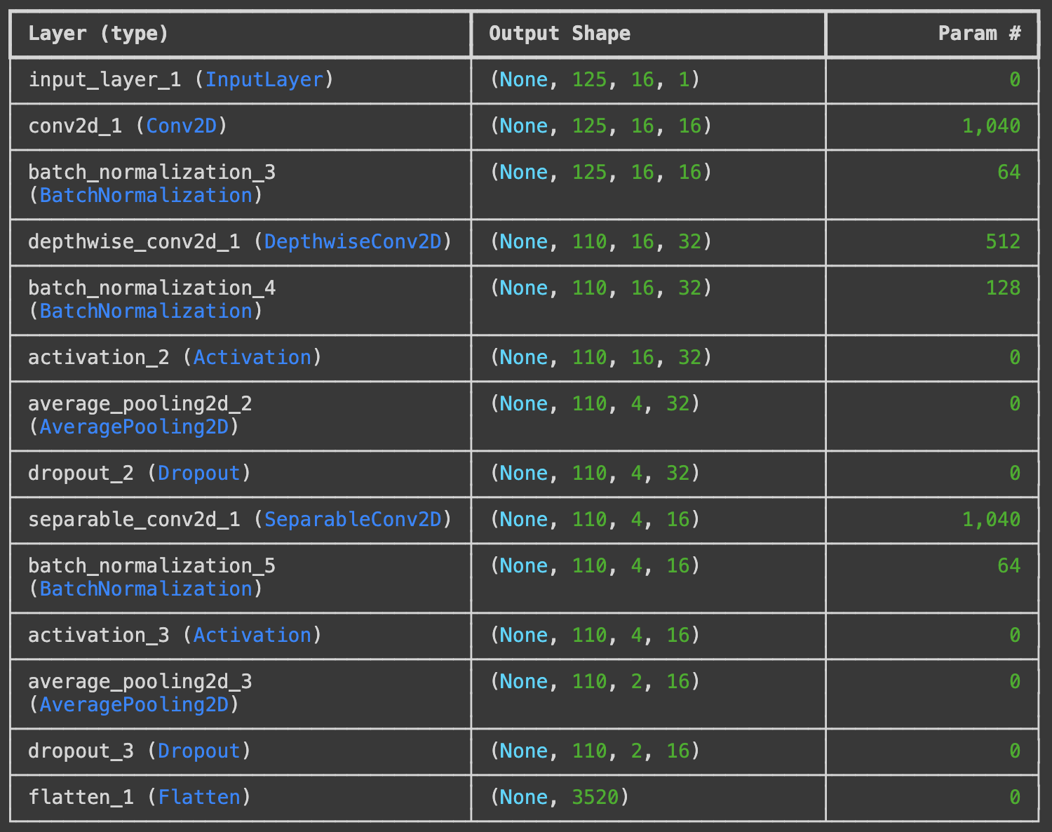

Instead of raw signals, pass frequency bands data - verify

Try with EEGnet:

1. Raw signals
2. Frequency bands

**Classification Results:**

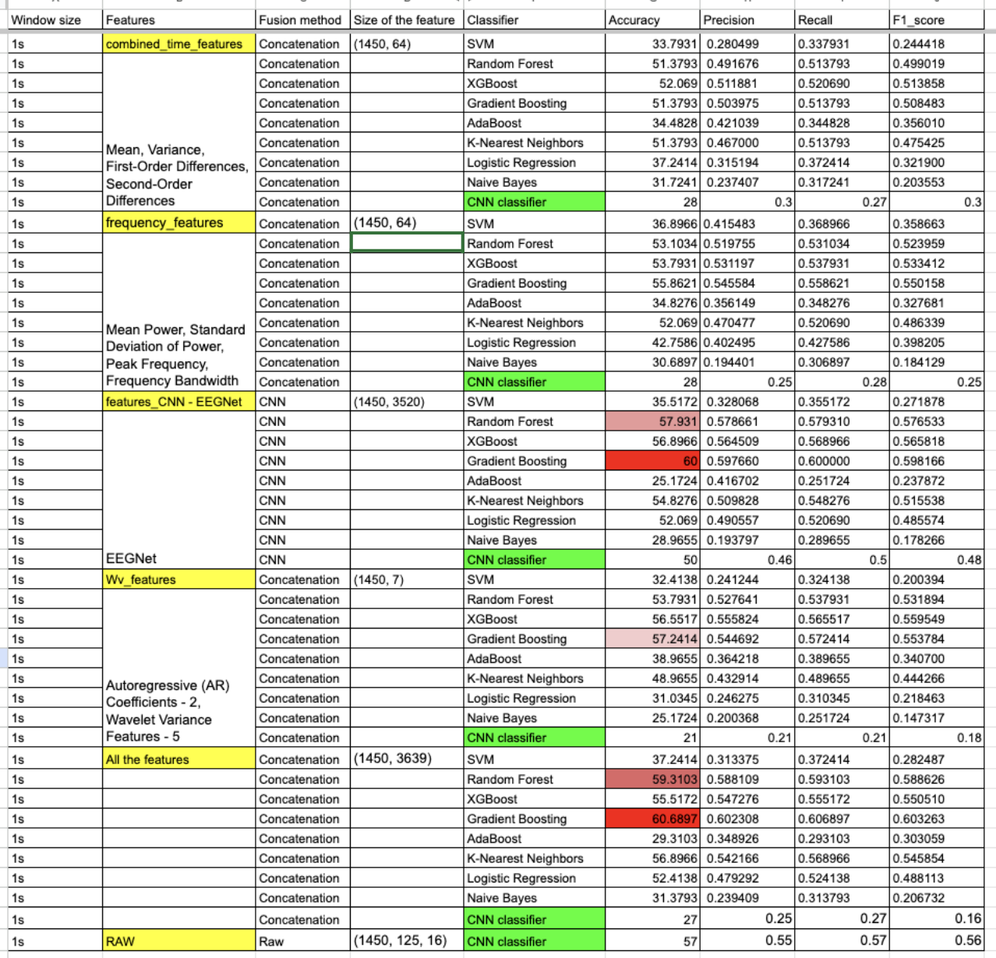

2 Fully connected layer - 100, 50(ReLu), 5(SoftMax) - Add to comparison

Best result: Concatenation of all the extracted features + Gradient Boost Classifier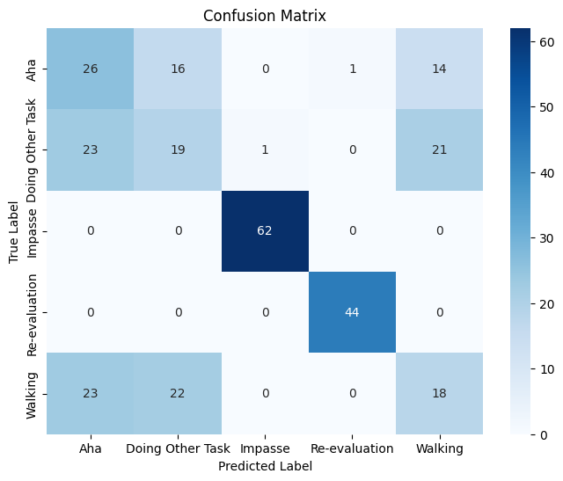

RoC Curve for All features

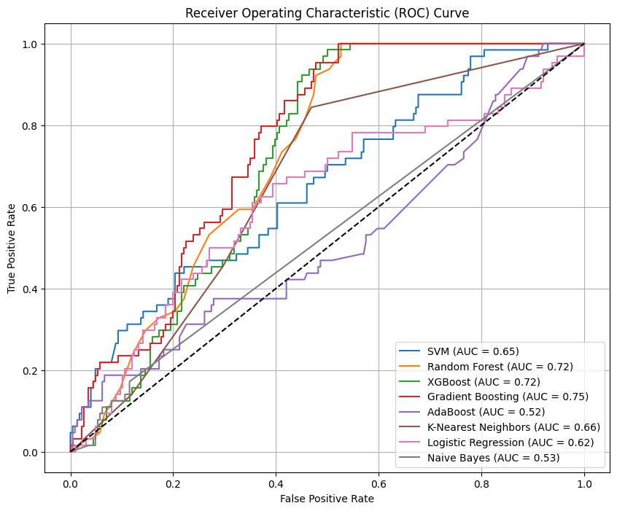

*Include CNN classifier to the curve

Todo:

1. **Improvise the labeling**
2. **Improvise Classification - Remove low performing classifiers**
3. **Extract CNN features with more blocks**
4. **Different feature fusion methods**